**Steps to install Swiftlint**

1. Go to terminal and type “**brew install swiftlint**” to install swiftlint. If you have already installed SwiftLint, you can update it to the latest version using the “**brew upgrade swiftlint**” command.

**Note:** Please update Homebrew to the latest version before installing and updating SwiftLint: **$ brew update.**

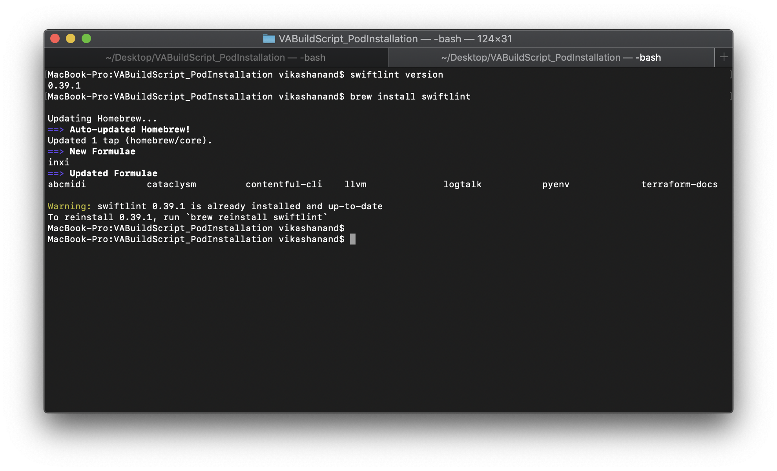

Since it’s already installed on my system, I am getting a warning that swiftlint is already installed but otherwise it will start the download process and eventually swiftlint will get installed.

**Note –** There are other ways to install swiftlint also like from cocoa pods or by downloading and installing a swiftlint package file but installing it from the brew is the preferred way.

For more details -[**Swiftlint Github page**](https://github.com/realm/SwiftLint)

1. After installing it, go to the root folder of your project in the terminal i.e.

**cd /*root_folder_path_for_your_project***

1. Then type command “**swiftlint rules**” in the terminal. This will show you all the rules and its properties that swiftlint has.

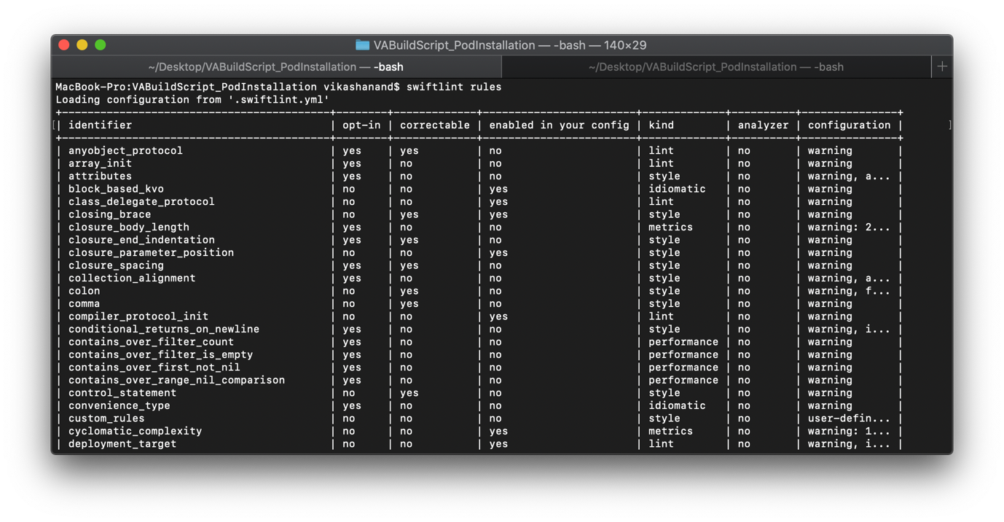

1. You can also define your own configuration file in which you can override the default rules and its property.
2. To define your configuration file create “.swiftlint.yml” file at the root level of your project.

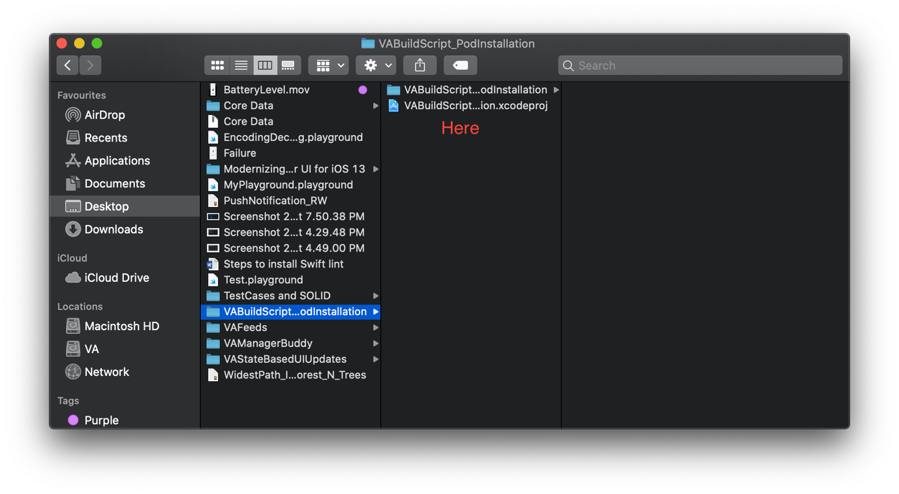

1. To create **“.swiftlint.yml**” configuration file, go to **XCode menu and select -> File -> New -> File…**
2. Then in the choose a “template for your new file” dialogue box, search “empty” (Under the other section) and save this file as “**.swiftlint.yml**” in the root folder of your project(as explained in step 5).
3. Also, while saving the file make sure that it is not included under any target i.e. targets box is unchecked.

**Note -** Since “.*files*” are hidden files so you wouldn’t be able to see “**.swiftlint.yml**” in the finder window.

There is neat keyboard shortcut to see the hidden files in finder window

**“command + shift + .”**

This keyboard shortcut will toggle the show hidden files to on and off alternately.

**Note -** This keyboard shortcut works on system having macOS High Sierra or above.

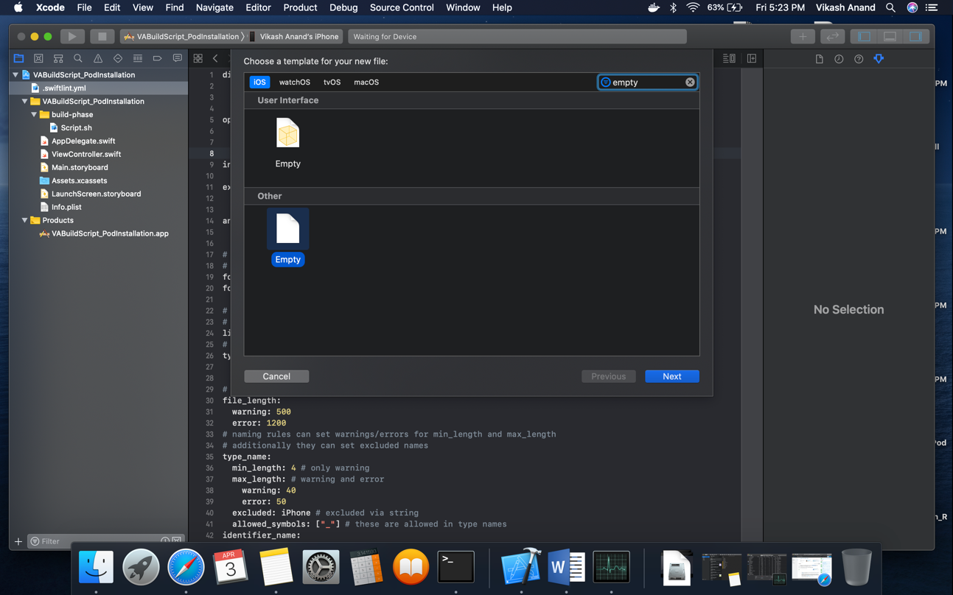

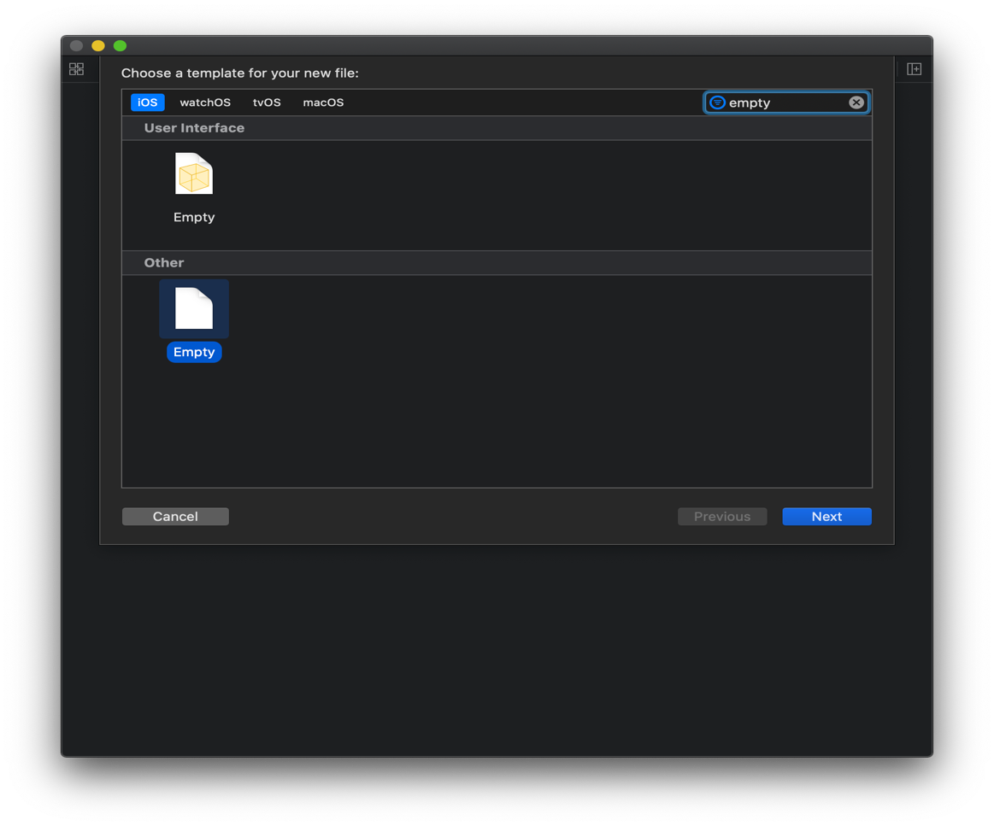

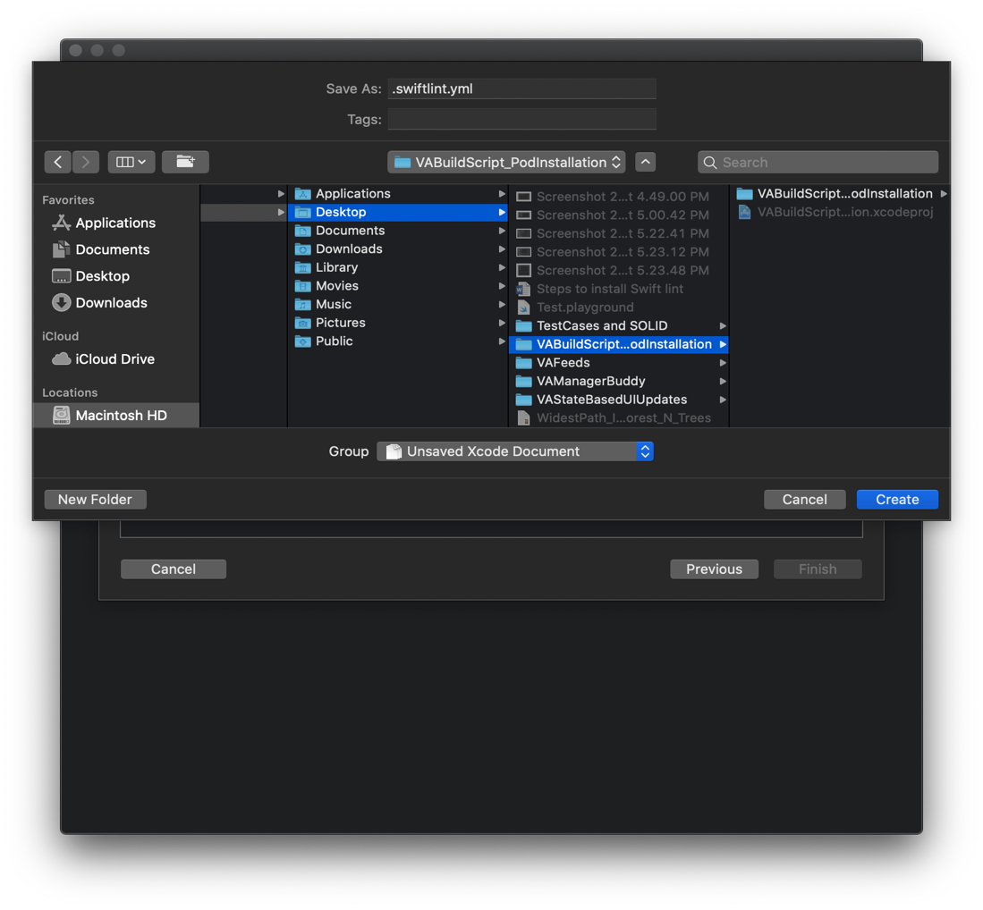

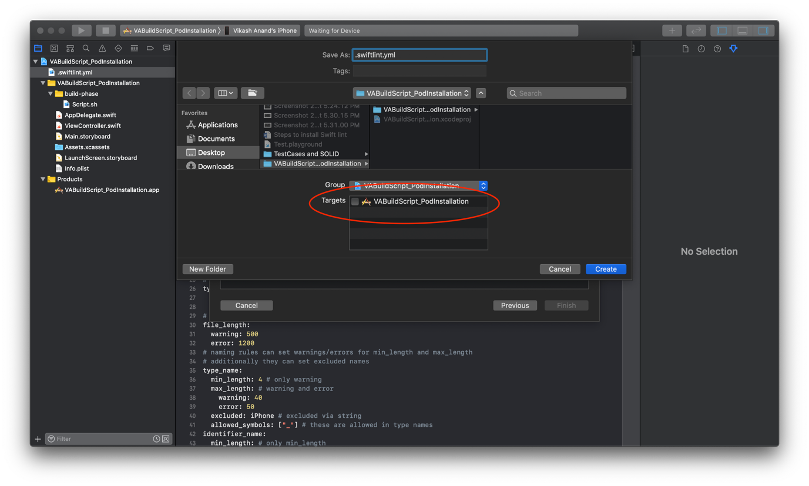

**How to use swiftlint in XCode**

1. Create “**build-phase**” directory at the following path in your project hierarchy

***ProjectRootFolder*/*ProjectFolder*/ build-phase**

1. Under **build-phase** directory create a “**script.sh**” file.
2. To create **script.sh**” file, go to **XCode menu and select -> File -> New -> File…**
3. Then in the choose a “template for your new file” dialogue box, search “shell script” and save this file as “**script.sh**” at path as explained in step 2.
4. Also, while saving the file make sure that it is not included under any target i.e. targets box is unchecked.

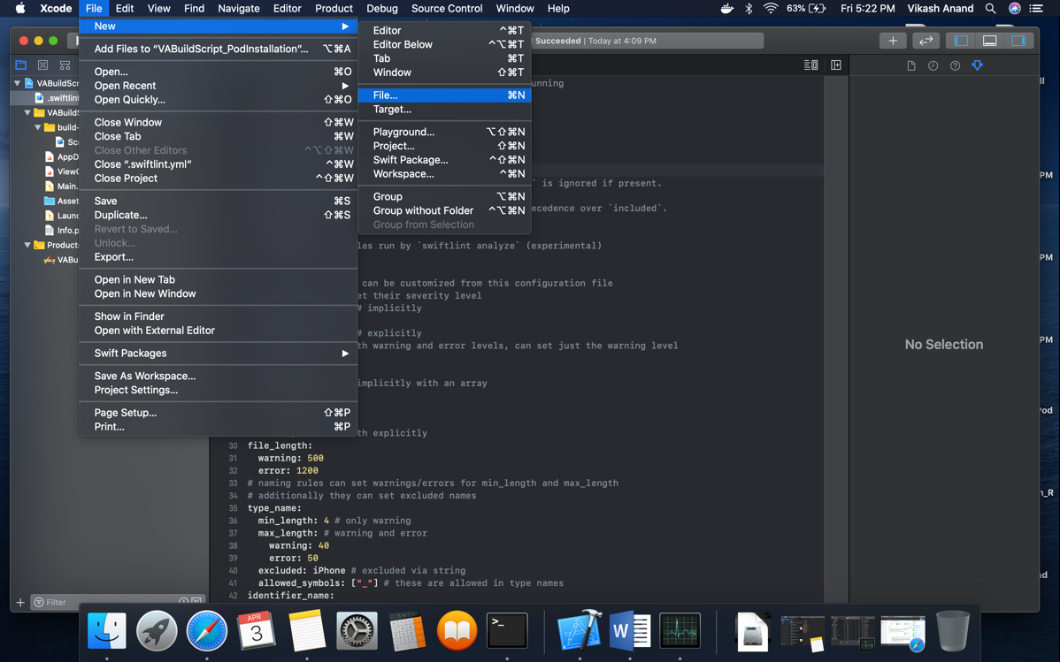

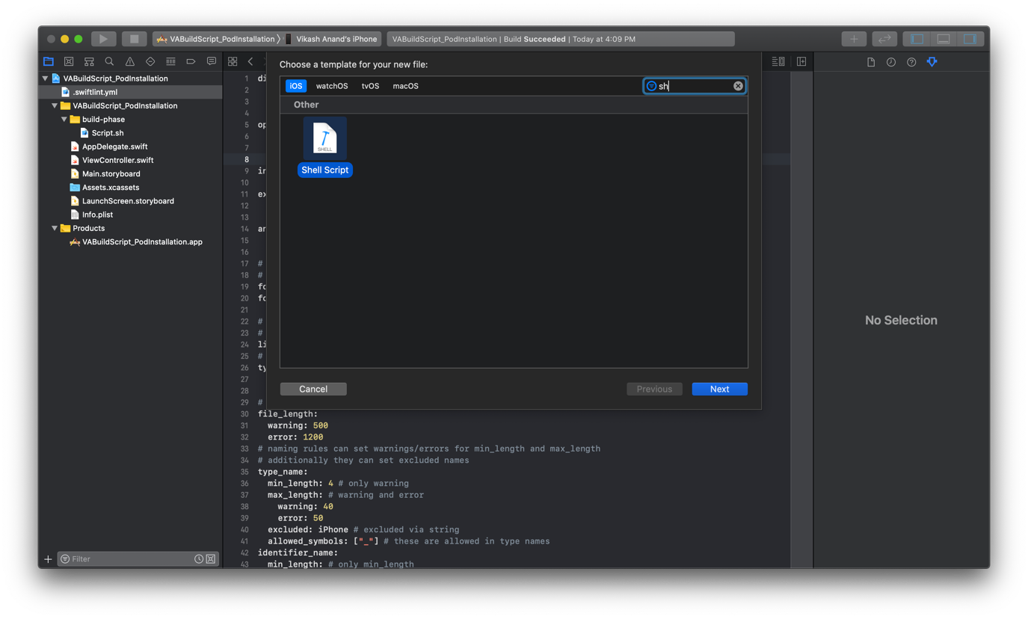

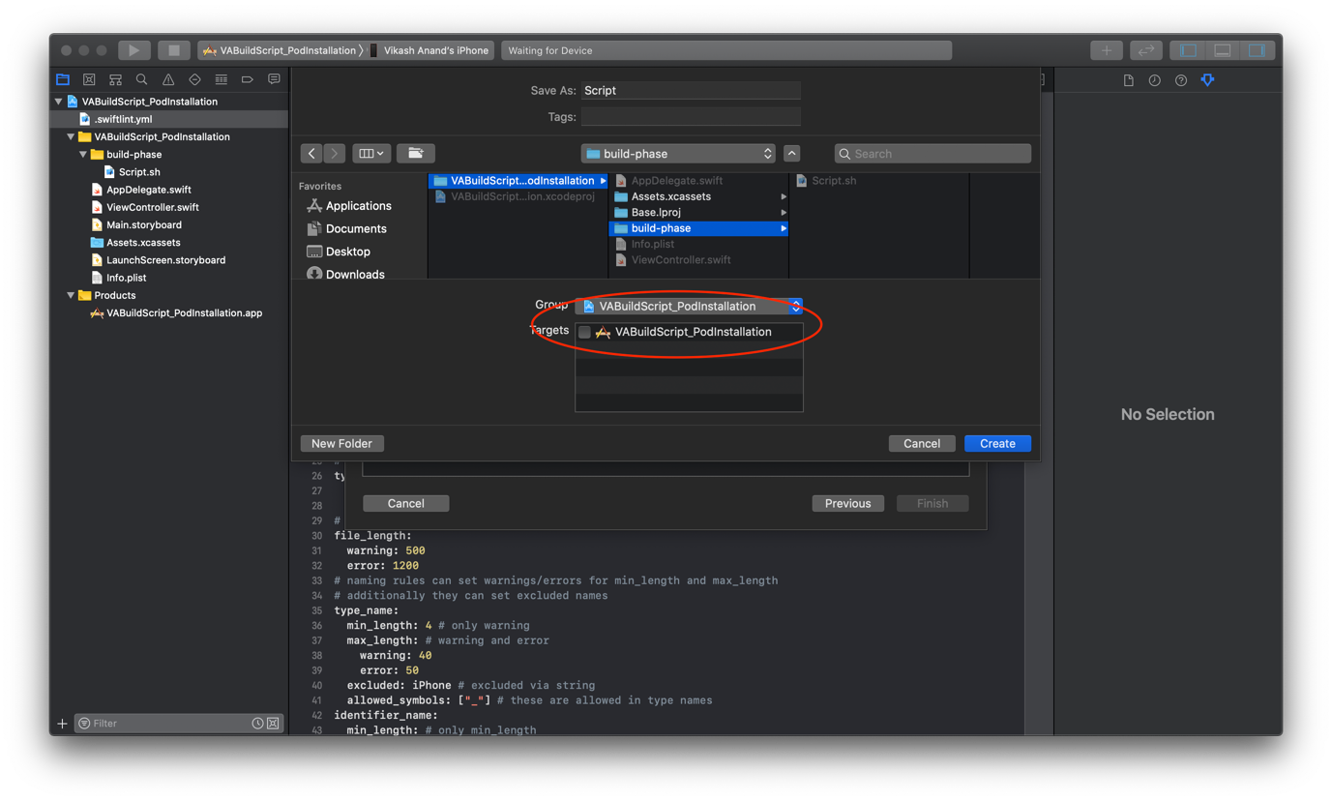

1. Now in the script.sh file add the following code

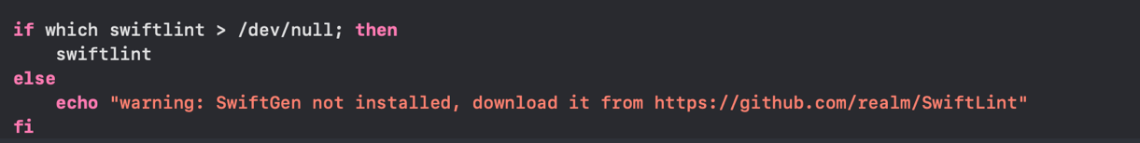

1. This is a script that checks for swiftlint during the XCode build process and gives a warning or error if swiftlint is not installed.
2. Now we will create a **user defined variable** that XCode will use to find out the path of the script file just created.
3. To create a **user defined variable**, select application target and then select “**Build Settings”**.
4. In “**Build Settings**” scroll to the bottom till the last section called “**User-Defined**”.
5. Now go to the **XCode menu -> Editor -> Add Build Setting -> Add User-Defined Setting**.
6. This will create a new row in the “**User-Defined**” section. Enter a name that will be used by XCode as variable that will hold the path for the “**script.sh**” file.
7. Naming convention for this script file path variable is all caps with under-scores as separator like following

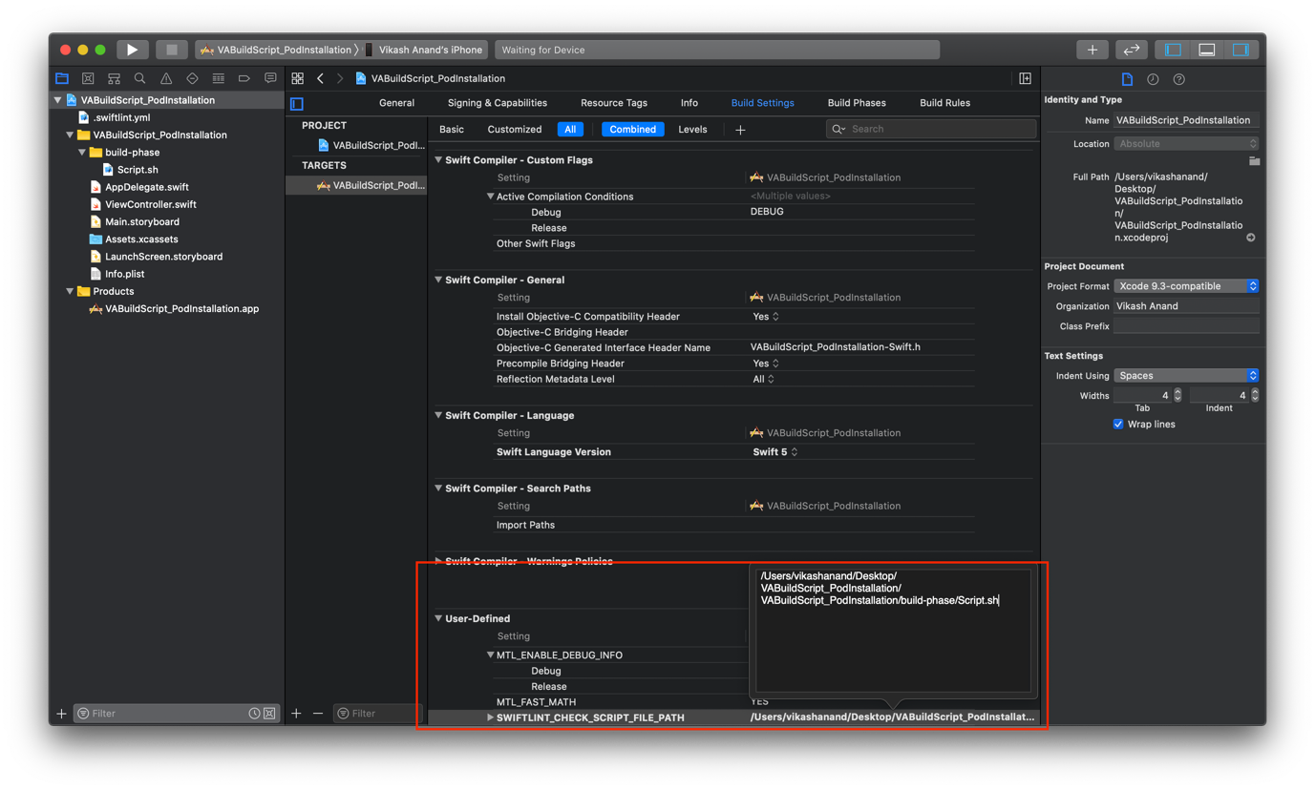

1. So, for name i am using “**SWIFTLINT_CHECK_SCRIPT_FILE_PATH**” and for value use

**${PROJECT_DIR}/*path_of_script.sh_file_inside_your_project_directory***

**Note –** You can hard code the “Script.sh” file’s path here but the problem with this approach is that if you move your project’s directory in the file system then this “Script” will start to fail as the hard-coded file path is no more correct. Benefit of using **${PROJECT_DIR}** is that I will automatically figure out the project directory’s path in the file system so no need to update script’s file path every-time you move your project.

1. Now go to “**Build Phases**” which just adjacent to the “Build Settings” section and click on “**New Run Script Phase**”.

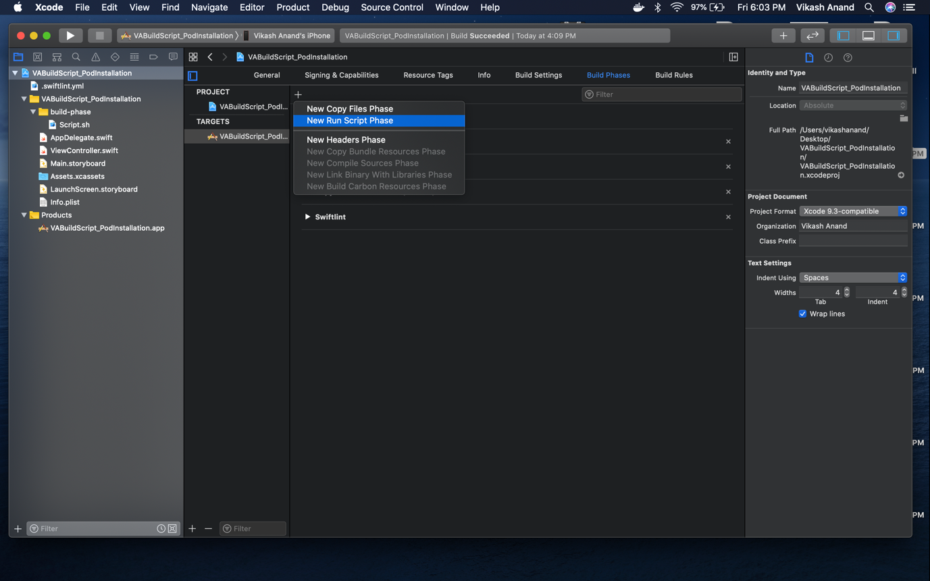

1. This will add a new section called “**Run Script**” in the “**Build Phases**".

**Note –** You can rename the “**Run Script**” header by double clicking on it.

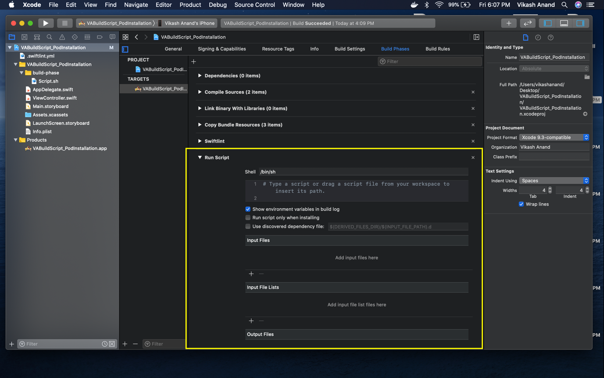

1. Now add the “**User Defined**” variable here that we have created in step 12.

**Note -** Make sure “**show environment variable in build log**” is checked. This will log your variable in the build log in case of error which will be helpful for debugging.

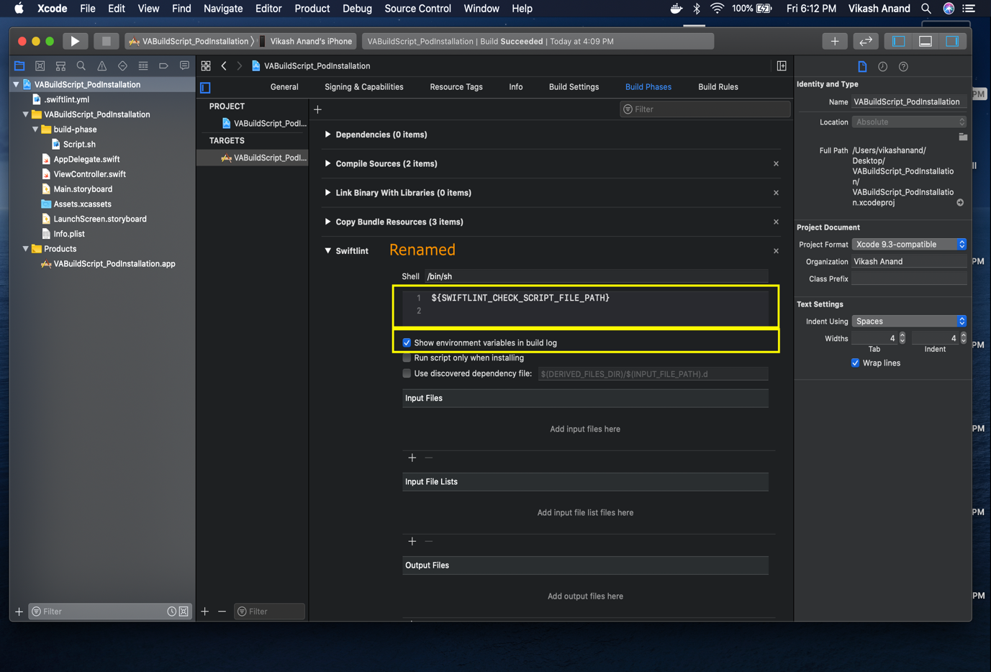

1. Now save, build your project and swiftlint should start giving you warnings / errors for all the code style violations.

**Other resources**

1. <https://handbook.infinum.com/books/ios/Tools/SwiftLint>
2. <https://www.avanderlee.com/optimization/swiftlint-optin-rules/>
3. <https://www.hackingwithswift.com/articles/97/how-to-clean-up-your-code-formatting-with-swiftlint>
4. <https://github.com/realm/SwiftLint/issues/1466>
5. <https://makoblog.com/organize-your-code-with-swiftlint/>
6. <https://github.com/realm/SwiftLint>
7. <https://realm.github.io/SwiftLint/rule-directory.html>

[**Github link for code sample**](https://github.com/DVdroid/VASwiftlLintWithBuildScriptCheck)